CT5026 –Algorithms & Software Design Assignment 1 – Software Report S1305610-Richard Dobie

Contents

1. Brief Overview 3

2. Propose Method Design 3

3. Software Life Cycle 3

4. Requirements Specification 4

4.1. Class Diagram 4

4.2 UML Use Case Diagram 5

4.3 UML Activity Diagram 5

4.4. UML Sequence Diagram 6

4.5 Z-Notation 8

5. Software Functionalities 9

6. Software Assumptions 9

7. Data Structure 10

8. Algorithm Justification 10

9. Software Testing 10

10. Software Results and Performance 10

10.1 Big O Notation 12

11. Conclusions 13

12. Video 13

12. References 13

Appendix A- TestCases 14

Black Box Testing 14

White Box Testing 14

Appendix B-Software Screenshots 15

# Brief Overview

The Software Designed and Created is Software which enables Users to Search for Train Times from Cheltenham Spa Train Station. The software created uses a Graphical User Interface to allow the User to enter or select their chosen Search Criteria. The Software returns results that match the Users Search Criteria displaying more information to the User. The Software is created in BlueJ using Java Language structured in an Object Orientated way. The Software uses a Linear Searching Algorithm to return results matching the Users search criteria.

# Propose Method Design

The Software is created following a method known as Object Orientated Design. The use of an Object Orientated approach helps structure the Code Efficiently. The use of this Method Design allows the Software to be designed as 3 classes with each class containing information pertaining to itself. The chosen Design Method helps organise and structure the Software in a coherent way.

# Software Life Cycle

To Design the Software a Software Life Cycle Model was followed in order to ensure all areas of the Software Analysis, Design and Implementation are thought about and allows the Creation of the Software to follow a Step by Step Method.

The Software Life Cycle used for developing this Software is the Waterfall Method. The Waterfall Method shown in Fig. 1 sets out 6 stages that need to be considered when the Software is being Designed, Developed and Maintained.

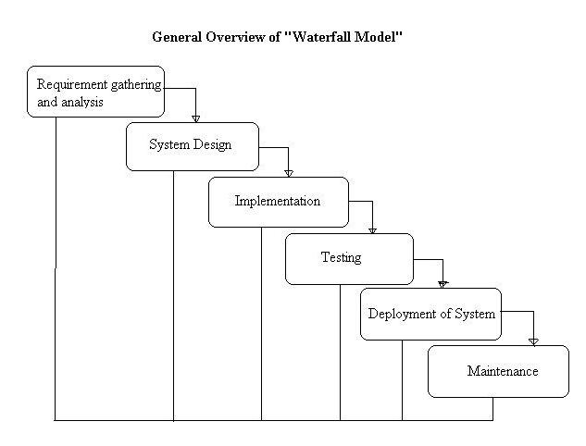

Figure 1: Waterfall Model (Web, 2015)

For each Stage of the Life Cycle Model the following actions were taken:

* **Requirement Gathering & Analysis**- Requirement Specification (UML and Z Notation)
* **System Design** – Object Orientated approach
* **Implementation** – use of 3 classes programmed in Java
* **Testing** – developed test cases
* **Deployment of System** – Software created is working and could be used
* **Maintenance** – well-structured and commented to allow other developers or users to understand code

# Requirements Specification

The requirements specification will detail and outline the applications specific requirements and functionality. The applications requirements and functionality will be outlined using UML Use Case Diagrams, UML Activity Diagrams and UML Sequence Diagrams. The purpose of these diagrams and a requirements specification is to give the developer of the application all the details needed in terms of the software/hardware requirements and the user requirements.

# 4.1. Class Diagram

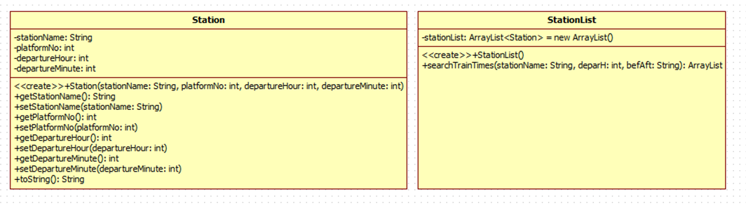Figure 2 displays the architecture of the developed software in terms of the class structures involved in the software

Figure 2: Class Diagram showing Structure of Software Classes

Figure 3 shows a screenshot in Bluej which shows the links between the classes involved in the system to highlight the relationships between the software classes.

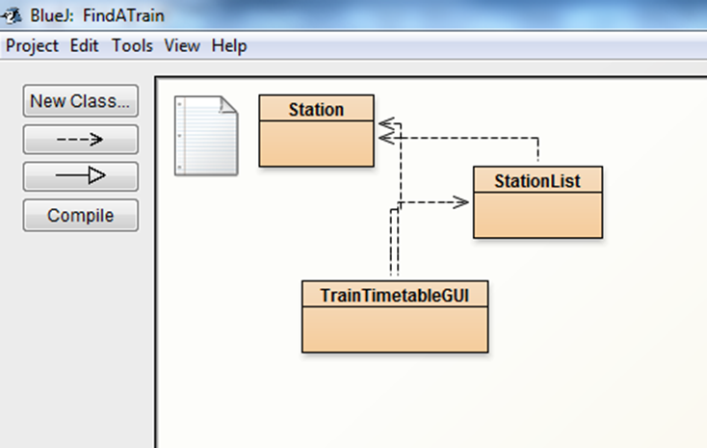

Figure 3: Class Diagram shown in BlueJ showing Software Links between the Classes

# 4.2 UML Use Case Diagram

Figure 4 shows the Use Case Diagram which is a visual representation of the interactions between the User and the System.

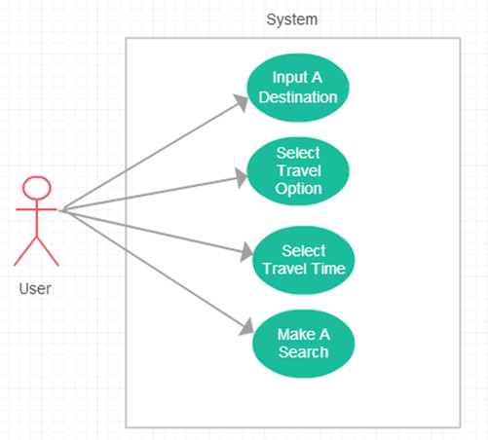

Figure 4: Use Case Diagram Visually Representing User Interaction with the Software

# 4.3 UML Activity Diagram

Figure 5 shows the activities associated within the first interaction the User makes with the software Interface. The Activities describe the steps associated with such an interaction with the system.

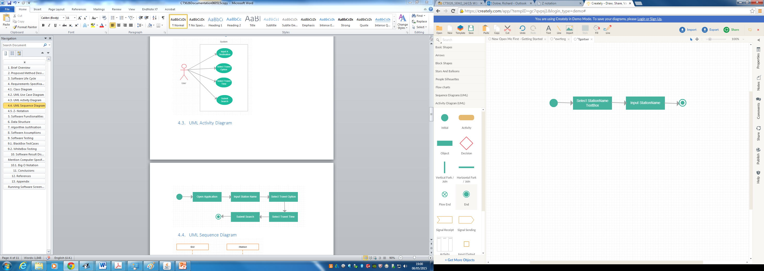

Figure 5: Activities associated with Input a Destination Use Case

Figure 6 shows the Activities associated within the second interaction the user makes with the software Interface. The Activities describe the steps associated with such an interaction with the system.

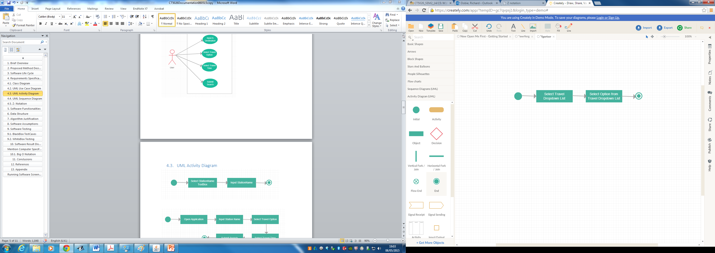

Figure 6: Activities associated with Select Travel option Use Case

Figure 7 shows the Activities associated within the third interaction the user makes with the software interface. The Activities describe the steps associated with such an interaction with the system.

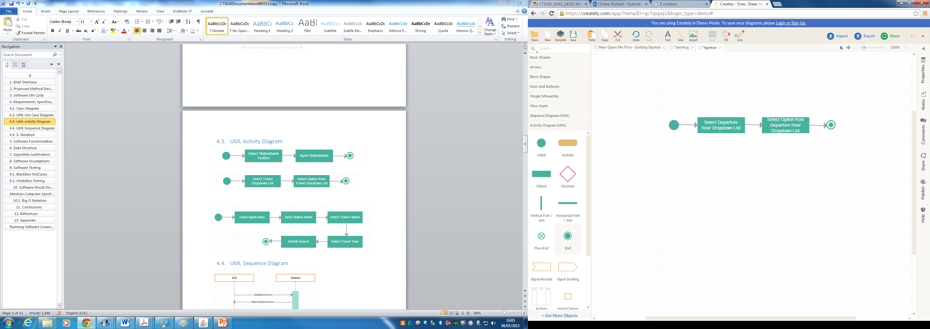

Figure 7: Activities associated with Select Travel Time Use Case

Figure 8 shows the Activities associated within the fourth interaction the user makes with the software interface. The Activities describe the steps associated with such an interaction with the system.

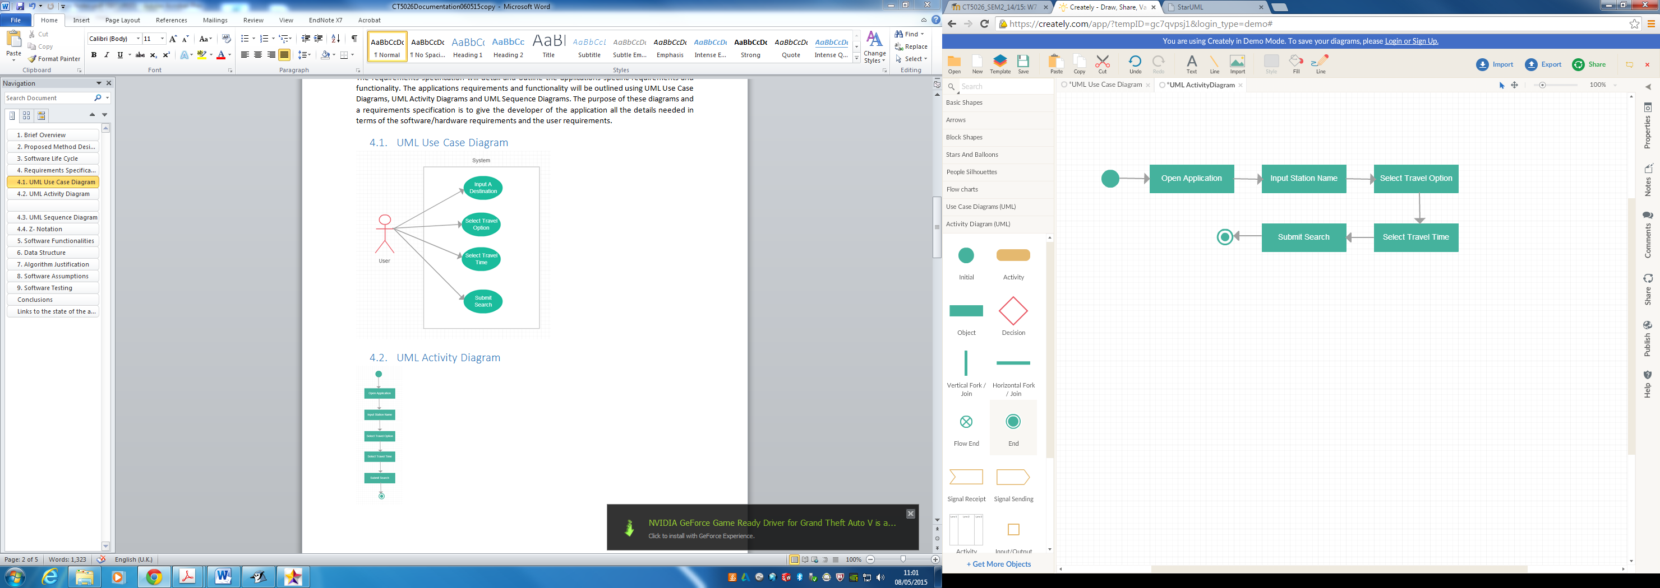

Figure 8: Activities associated with User making a search

# 4.4. UML Sequence Diagram

Figure 9 shows the software sequence involved with inputting a destination to the software and describes the methods taken by both the software Interface and the Station Class.

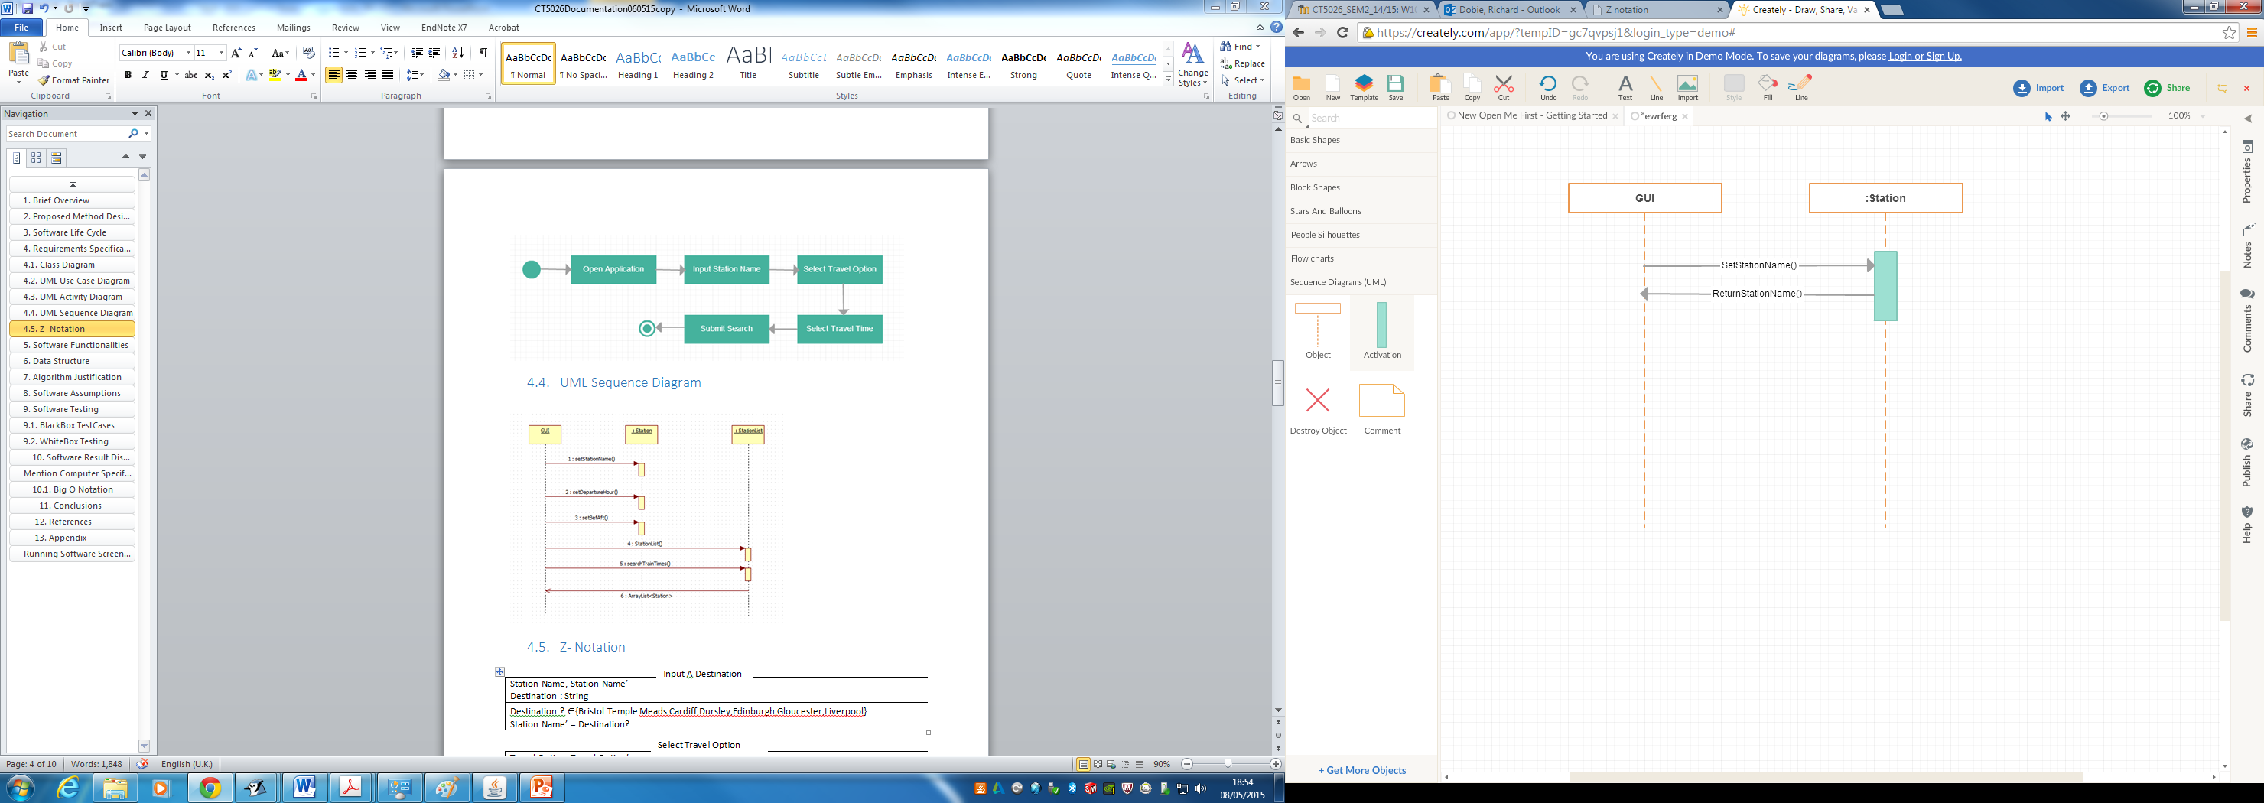

Figure 9: Software Sequence for Inputting a Destination Use Case

Figure 10 shows the software sequence involved with selecting a departure hour option from a combo box within the software and describes the methods taken by both the software Interface and the Station Class.

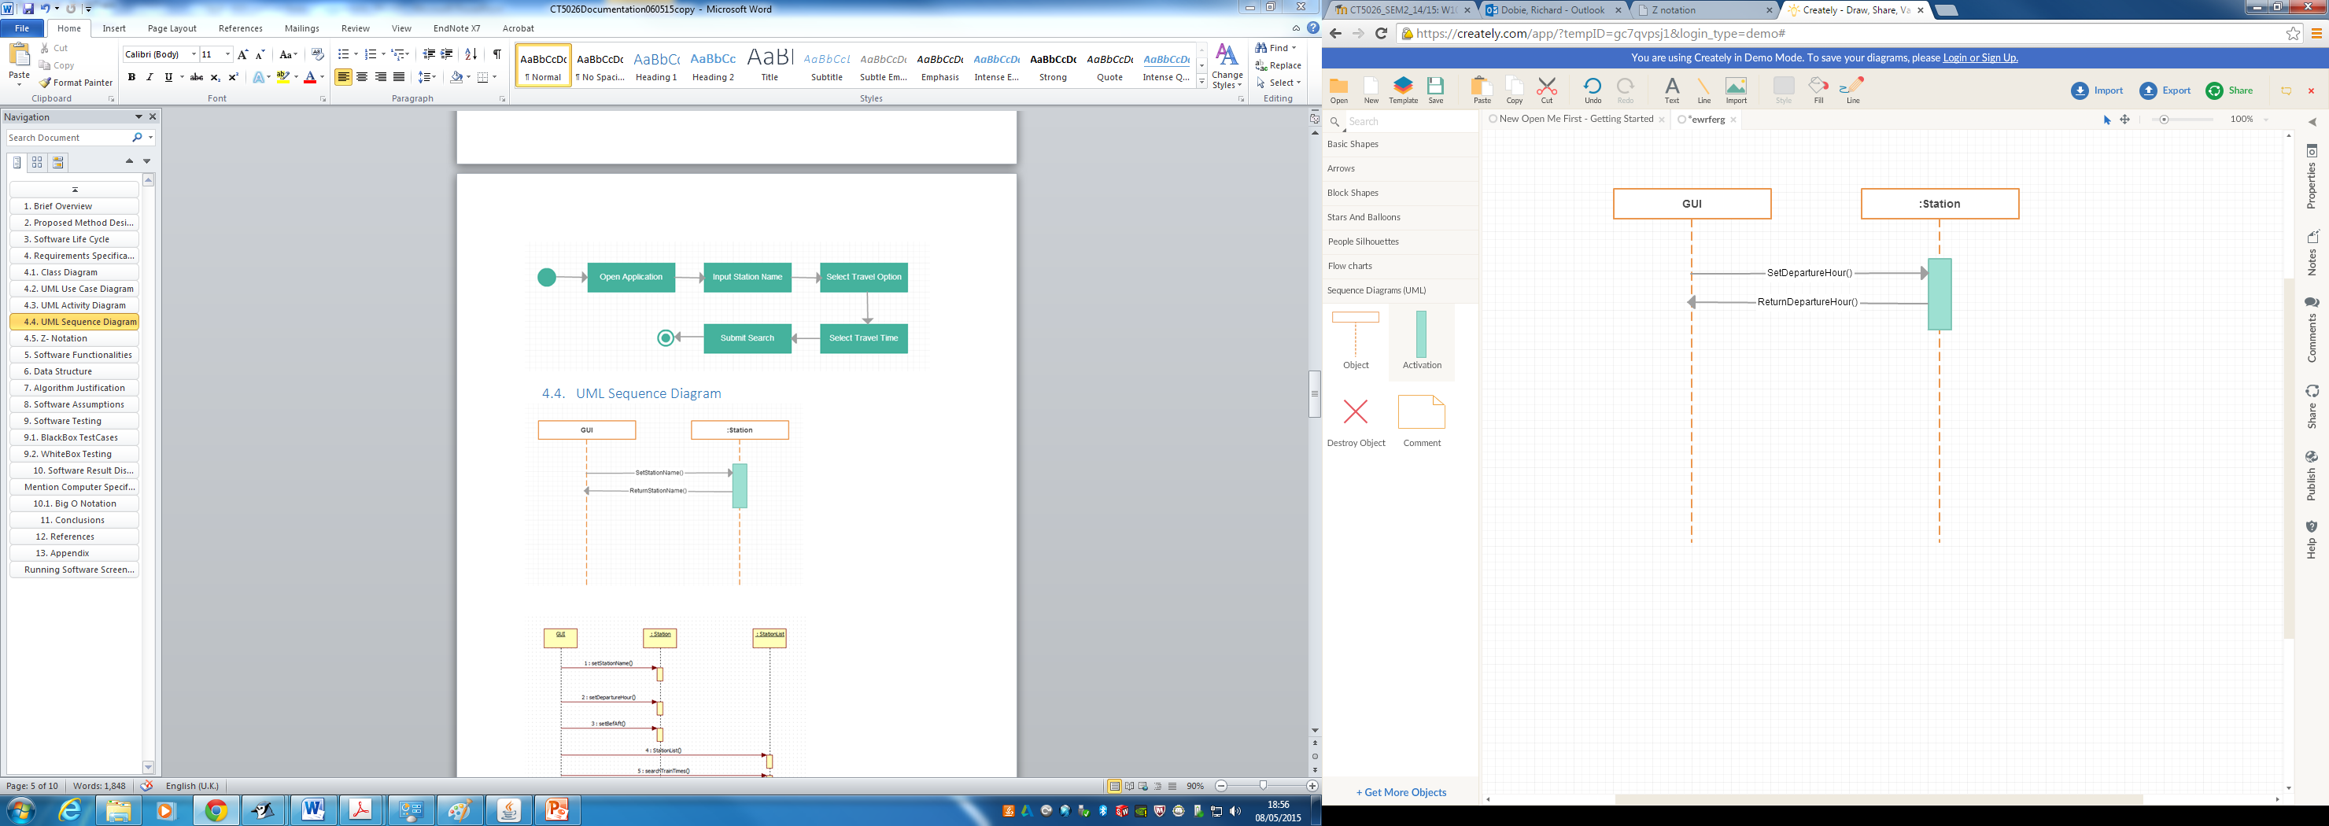

Figure 10: Software Sequence of selecting Travel Option Use Case

Figure 11 shows the software sequence involved with selecting a travel option from a combobox option within the software and describes the methods taken by both the software interface and the station class.

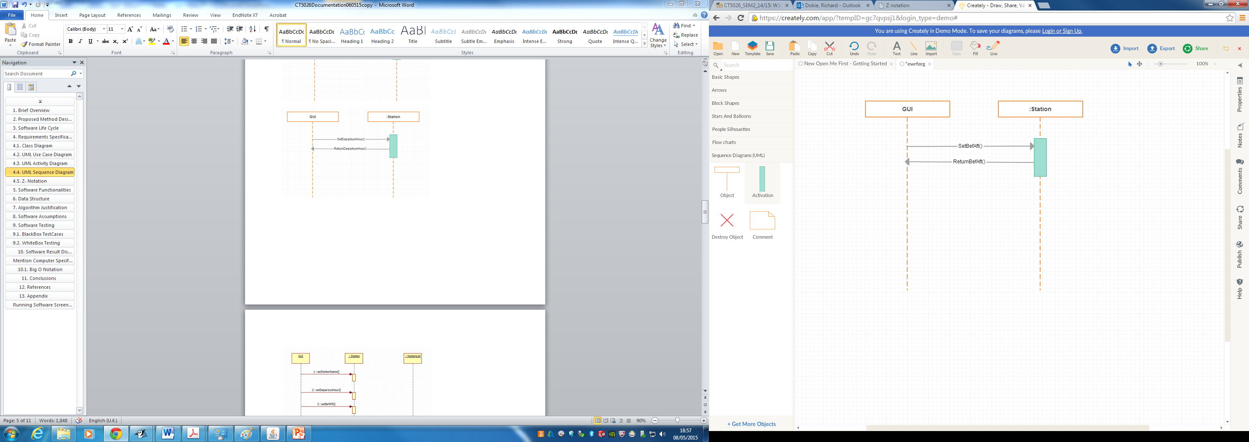

Figure 11: Software Sequence of selecting Travel Time Use Case

Figure 12 shows the software sequence involved with making a search and describes the methods taken by both the software Interface, Station Class and Station List Class.

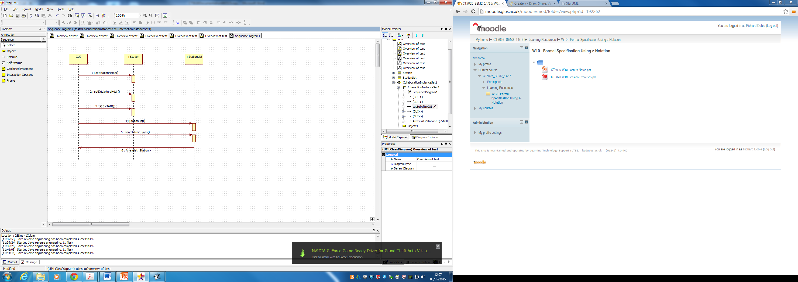

Figure 12: Software Sequence of making a search Use Case

# 4.5 Z-Notation

The Z schema below displays the Structure and functionalities involved in each interaction with the software and describes the relationships between the class structures.

The Z Schema below describes the Class Structure in an unambiguous format showing the Logic of the class

Input A Destination

|  |
| --- |
| Station Name, Station Name’  Destination : String |
| Destination ? {Bristol Temple Meads,Cardiff,Dursley,Edinburgh,Gloucester,Liverpool}  Station Name’ = Destination? |

Figure 13: Input a Destination Z Schema

The Z Schema below describes the Class Structure in an unambiguous format showing the Logic of the class.

Select Travel Option

|  |
| --- |
| Travel Option, Travel Option’  Travel Option ::= Before|After |
| Travel Option Before  Hour  Travel Option After  Hour |

Figure 14: Select Travel Option Z Schema

The Z Schema below describes the Class Structure in an unambiguous format showing the Logic of the class.

Select Travel Time

|  |
| --- |
| Hour : N |
| Hour ?  {0,…..,23} |

Figure 15: Select Travel Time Z Schema

The Z Schema below describes the Class Structure in an unambiguous format showing the Logic of the class.

Make A Search

|  |
| --- |
| Platform : Integer  Departure Hour : Integer |
| Platform ?  {1,2}  Hour ?  {0,….,23}  Search ‘ = Platform?  Hour? |

Figure 16: Make A Search Z Schema

# Software Functionalities

The software systems functionalities used within the application are functionalities that have been modelled on existing applications that are available online which allow train times and information to be searched for by users of such applications.

The software functionalities incorporated into the Find A Train Application are modelled closely to an existing application used on National Rail Enquiries. The Software Functionalities used in Find A Train include the following:

* The Software allows the User to enter a destination of their choice
* The software allows the User to pick when they would like to travel
* The Software allows the User to create a Search Query
* The Software returns relevant results that match the Users Search Query

# Software Assumptions

The software assumptions contained within the application are assumptions included in the software to narrow down the size and complexity of the software to allow the software to be able to be designed and implemented in the given time frame. The software assumptions are both advantageous by means of allowing a simple software application to be designed and implemented which implements the use of an algorithm to perform the functionality of the software. The disadvantage of software assumptions is that it restricts the Users Search Criteria.

The software assumptions incorporated into the application include the following

* The dataset contains 6 possible Destinations
* The dataset contains 10 possible train times for each destination

# Data Structure

The Data Structure of the software consists of the use of Arrays and Array Lists which are linear Direct Access. The use of these data structures within the software is to store the dataset information in an efficient way within a computer’s memory. The advantage of the Array and Array Lists is that information can be retrieved directly as the information is stored and retrieved due to the use of the key value to identify. The Dataset used within the application is stored as a Linear Sequential Access List. The benefit of storing the data in such a structure allows the Software Algorithm to be more efficient and less time consuming to finding data information that matches a user’s search criteria.

# Algorithm Justification

The software application requires a searching Algorithm in order to be able to carry out the software functionalities. The decision on the most appropriate Algorithm to carry out the software’s functionalities was made by considering two different Searching Algorithms.

The two Searching Algorithms that were looked at included a Binary Search and Linear Search Algorithm. The Algorithms were looked at to determine the most appropriate to be able to carry out the software’s functionality as efficiently as possible.

The consideration of the Binary Search Algorithm was due to the fact that the Algorithm uses a technique called divide and conquer which involves the algorithm making less comparisons against the data which would make the algorithm efficient at returning results. The disadvantage of the binary search is that it is more suited to only finding a single result.

The consideration and use of the Linear Search Algorithm was due to the fact that the linear search algorithm can be just as efficient as the binary search algorithm with the benefit that the linear search algorithm is more suited to searching and returning multiple results

# Software Testing

The Software was tested using two types of Testing called White Box and Black Box testing. The white box Testing tests how the Software implements each constructor and method in the program. The black box tests test the implementation of the system from a User’s perspective.

The test cases can be seen in Appendix A.

# 10. Software Results and Performance

The Software performance and Functionality was tested using test cases as seen in Appendix A. The results from these tests and the Big O Notation Table as seen in Fig … shows how the Algorithms Performance is dependent on the Computer Spec the Application is being run on. The Computer Spec used for testing the Application is shown below in Fig 17 & 18.

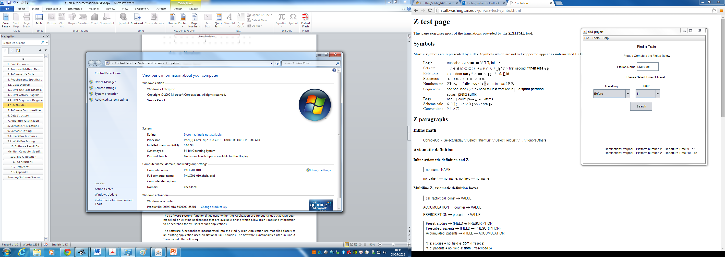

Figure 17: Specifications of University Machine PKLC201-010

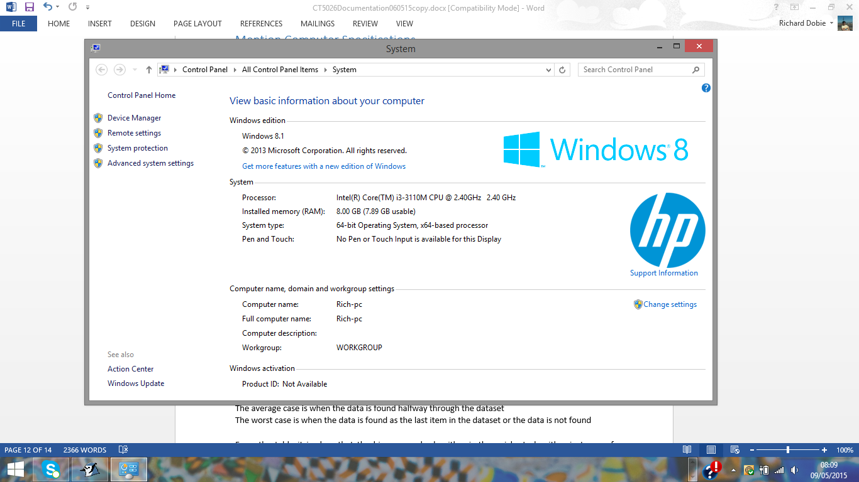

Figure 18: Specifications of Personal Laptop

# 10.1 Big O Notation

The table seen in Table 1 shows the Big O Notation for the Linear Search. The table in Table 1 shows the performance of the algorithms in terms of searching for Data and how Fast the Algorithm performs. The table shows the best, average and worst case performance of the Algorithm and the Speed in which the Algorithm executes.

* The best case is when the data is found as the first item in the dataset
* The average case is when the data is found halfway through the dataset
* The worst case is when the data is found as the last item in the dataset or is not found

The Linear Algorithm speed is carried out in Real Time which suggests the Algorithm is very efficient and appropriate in carrying out the Software’s Functionality.

Table 1: Big O Notation Comparison of Algorithms

|  |  |  |  |  |  |  |  |
| --- | --- | --- | --- | --- | --- | --- | --- |
| Algorithm | Description | Big O | Best Case | Average Case | Worst Case | F(N) | Running Time (milliseconds) |
| Sequential Search | Linear | O(n)  -  60 | O (1) | O (n) | O (n) | N | 0 |
| Sequential Search | Linear | O(n)  -  6000 | O(1) | O(n) | O(n) | N | 906 |

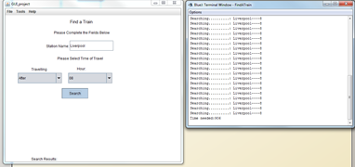

Figure 19: Screenshot showing the performance of the algorithm when making a search

Fig 19 shows a search being made and the performance of the algorithm being calculated. The dataset was too small to test originally so extra test data was added and the total amount of data was multiplied by 1000 to be able to test the algorithms true performance.

# 11. Conclusions

The conclusions gained from creating the software following the adopted Design Methods outlined and discussed throughout the report has enabled the software to be created to carry out the required functionality through the use of an appropriate Algorithm to execute the Software’s Functionality. The software has disadvantages due to certain limitations and constraints to the system which would be implemented differently if the software was to be improved in the future. The software constraints would be changed to allow the software to return a greater variety of Results applicable to all possible destinations a User could travel to from Cheltenham Spa. The software functionality could be improved to provide additional functionality such as the ability to book tickets and other functionality which would reflect existing applications discussed in Section 5.

The software has been designed and developed taking into account Ethical Issues such as ensuring the dataset used in the system and all corresponding code has not been passed off as my own work and any code or data which is not my own work has been referenced according to the Harvard Reference Standards. The software has been tested to make sure that it works correctly and doesn’t contain any viruses or anything that could be harmful to a User’s Computer System.

# 12. Video

The Video showing the Software Running and being used can be viewed using the following link <https://www.youtube.com/watch?v=bJGtMKolE9A>

# 12. References

Algs4.cs.princeton.edu, (2015). BinarySearch.java. [online] Available at: http://algs4.cs.princeton.edu/11model/BinarySearch.java.html [Accessed 29 Apr. 2015].

Example?, W. (2015). Testing Basic Interview Questions : What Is Functional Testing Explain It with Example?. [online] Testingbasicinterviewquestions.blogspot.co.uk. Available at: http://testingbasicinterviewquestions.blogspot.co.uk/2012/01/what-is-functional-testing-explain-it.html [Accessed 28 Apr. 2015].

Istqbexamcertification.com, (2015). What is Waterfall model- advantages, disadvantages and when to use it?. [online] Available at: http://istqbexamcertification.com/what-is-waterfall-model-advantages-disadvantages-and-when-to-use-it/ [Accessed 26 Apr. 2015].

Slideshare.net, (2015). Data Structures- Part3 arrays and searching algorithms. [online] Available at: http://www.slideshare.net/alhazmy13/part3-arrays-and-searching-algorithms [Accessed 1 May 2015].

Slideshare.net, (2015). MELJUN CORTES Jedi slides data st-chapter01-basic concepts and notati…. [online] Available at: http://www.slideshare.net/MELJUN2009/jedi-slides-data-stchapter01basic-concepts-and-notations [Accessed 1 May 2015].

Www2.hawaii.edu, (2015). Analysis of Binary Search. [online] Available at: http://www2.hawaii.edu/~janst/demos/s97/yongsi/analysis.html [Accessed 1 May 2015].

Weiss, M. (2006). *Data structures & problem solving using Java*. Boston, MA: Pearson/Addison-Wesley.

# Appendix A- TestCases

## Black Box Testing

|  |  |  |  |  |  |
| --- | --- | --- | --- | --- | --- |
| Test ID | Test Name | Test Description | Expected Outcome | Actual Outcome | Pass/Fail |
| 000001 | Input Destination | User Inputs a Destination they wish to travel to | User inputs a suitable Train Station Destination | User Inputs a Suitable Train Station Destination | Pass |
| 000002 | Select Travelling Option | User Selects whether they wish to travel “Before” or “After” | User Selects an option from the drop down list | User selects an option from the drop down list | Pass |
| 000003 | Select Departure Hour | User selects a departure Hour from the drop down list | User selects an option from the drop down list | User selects an option from the drop down list | Pass |
| 000004 | Click Search Button | User clicks Search button to submit search query | User clicks search button | User clicks search button | Pass |

## White Box Testing

|  |  |  |  |  |  |
| --- | --- | --- | --- | --- | --- |
| Test ID | Test Name | Test Description | Expected Outcome | Actual Outcome | Pass/Fail |
| 000001 | Method | Tests the set/get methods | Should display data corresponding to each set and get method | Displays data corresponding to get and set methods | Pass |
| 000002 | Constructor | Tests data is stored in Array | Should display all data | Displays all data | Pass |
| 000003 | Search | Tests search algorithm | Should find no results for incorrect search and should find 8 results for correct search | Finds no results for first search and 8 results for second search | Pass |
| 000004 | Branch | Tests the IF statements | Should return results if criteria matches | Returns results | Pass |
| 000005 | Big O Notation | Tests speed of search | Should return speed of search | Returns speed of search | Pass |

# Appendix B-Software Screenshots

Figure 19 shows the Application Interface when loaded by the User all GUI Text fields and Dropdown Boxes load Initially Blank as User has not made any selections yet.

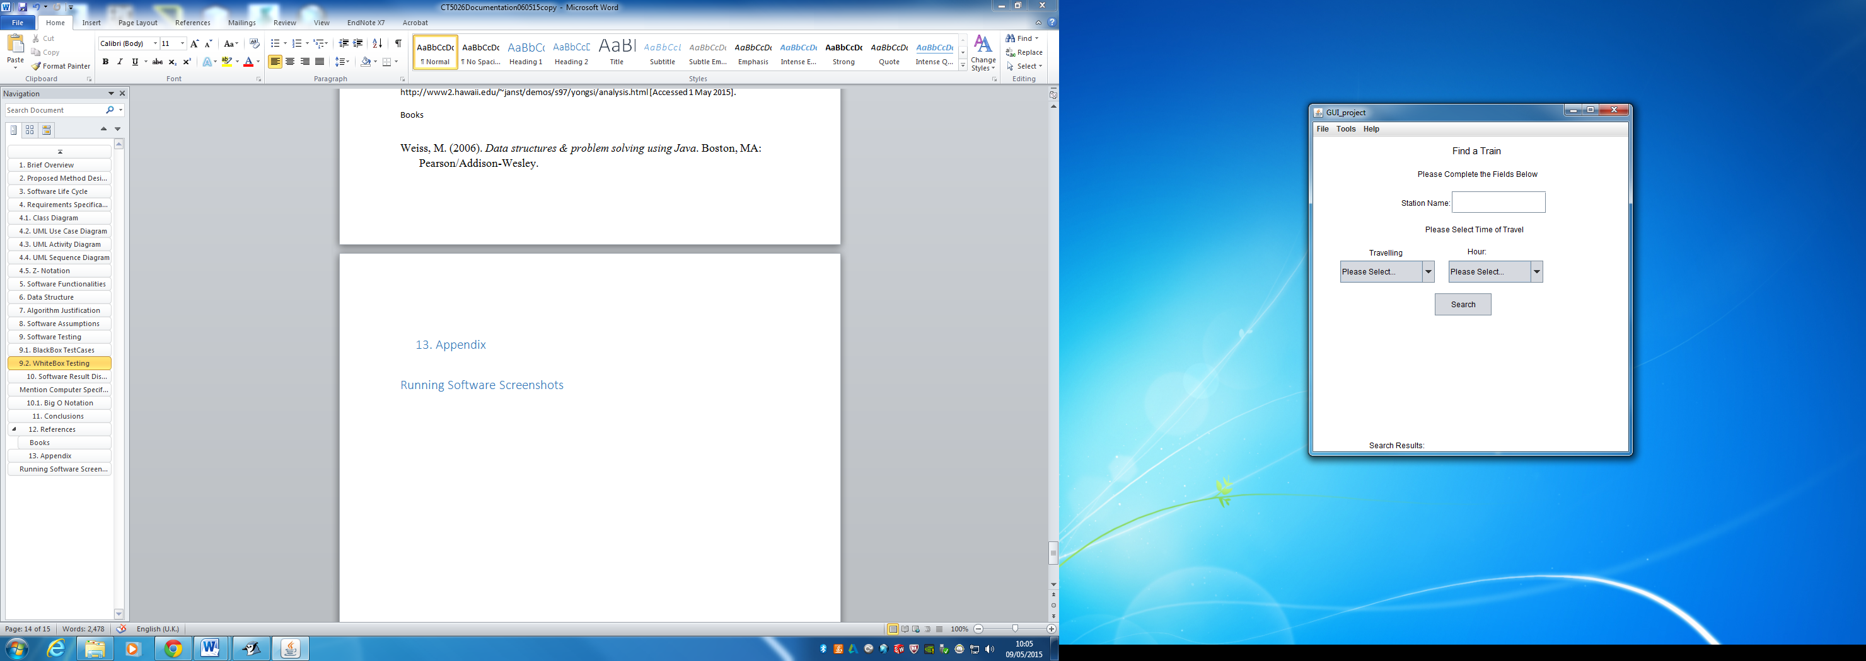

Figure 20: Initial Screen when Application Loads

Figure 20 shows the User Interacting with the Interface to enter a Destination to start the search.

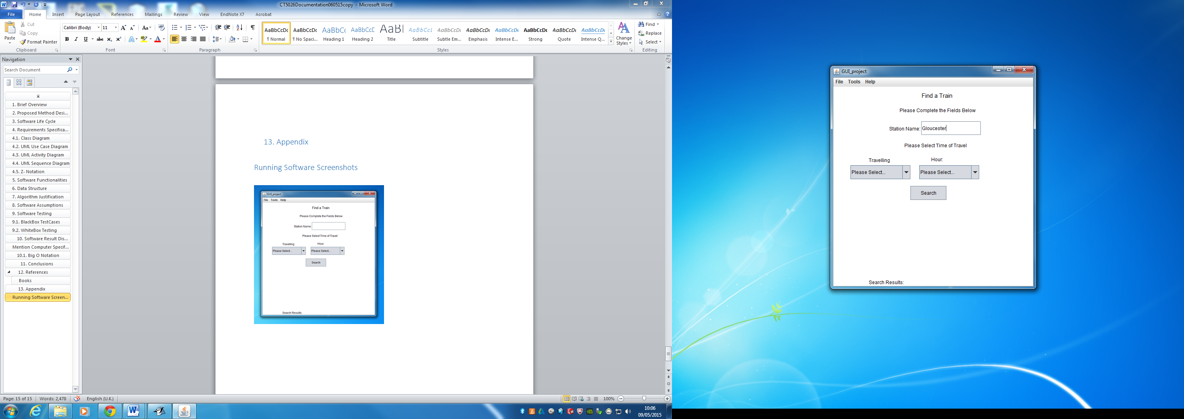

Figure 21: User Inputs A Destination

Figure 21 shows the User Interacting with the Interface to select a travelling Option from the Dropdown List

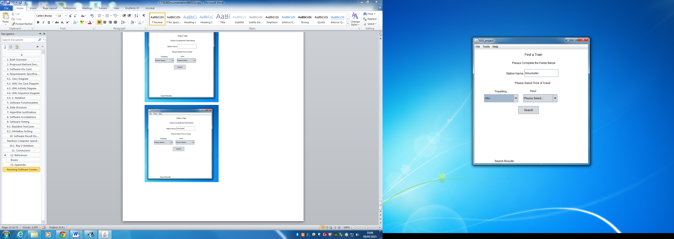

Figure 22: User selected travel option

Figure 22 shows the User Interacting with the Interface to select a Travel Time from the Dropdown List

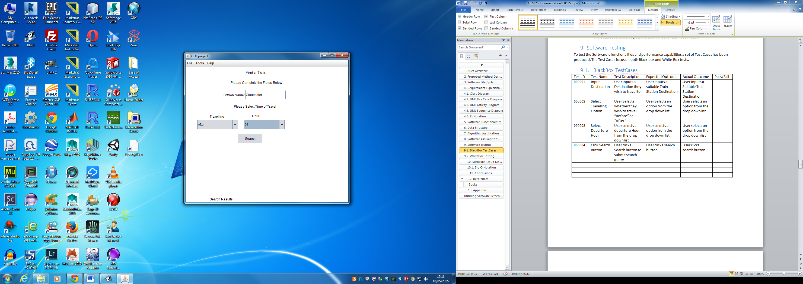

Figure 23: User selects a travel time

Figure 23 shows the User Interacting with the Interface to make a search and the Interface has returned appropriate results.

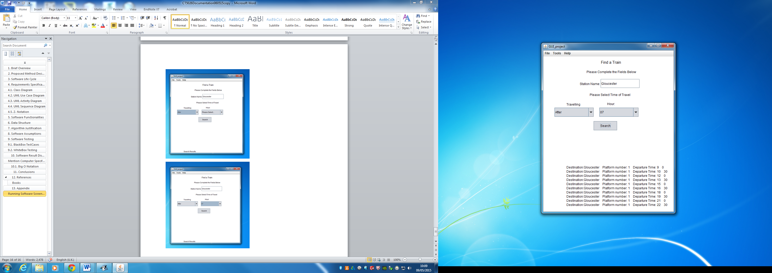

Figure 24: User has made a Search